Recovering from a damaged db. Missing/corrupted forms or controls.

In this sample recovery document, I will detail the steps to export the data and then sample the data and add missing data into a new or working db. I may miss some details as every db is setup differently.

*ALL USERS MUST LOG OUT OF THE DB AND NO NEW DATA MUST BE ADDED. STAFF MEMBERS CAN JUST NOTE THEIR DATA ON PAPER WHILE THE SCHEDULE PROCESS IS IN PLACE.

1. Import tables from “corrupted db” to a blank db.
2. Import tables from “current db” to the same blank db.
3. Check all the tables, and add the current db’s table records in each table to the “corrupted db’s” table records.
4. Verify all tables.
5. Export all the tables into a good backup db.
6. Open the backup db.
7. Compact and repair the db.
8. Test the db. Verify all the tables.
9. Deploy the db onto the network. Make sure the db name is exactly as before so all shortcuts will work.
10. Set backup appropriately and schedule a maintenance schedule for db.

Step #1. Open a blank db. This is to import in the data tables and examine the tables for missing data.

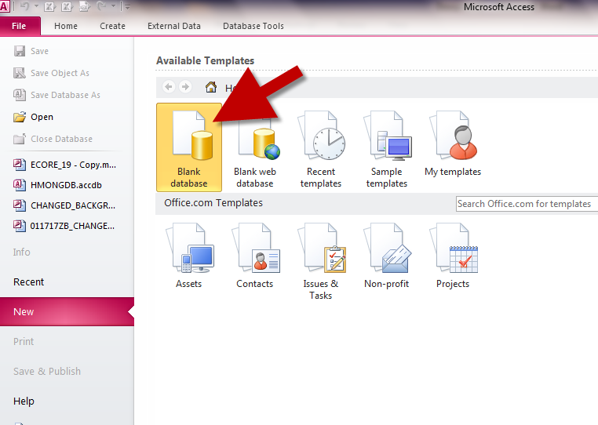

Step #2. Create a new db and click on the external data. You do not neccerily have to see all the MSys objects. If the list is blank, it is just your settings. This is where we will import the table from the corrupted db.

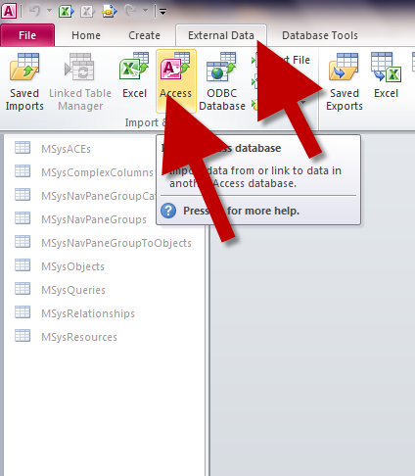

Step #3. After clicking on the Access option under the external data. You will get the following screen. Click on the “Browse” and browse to the “corrupted db that you need the data from.

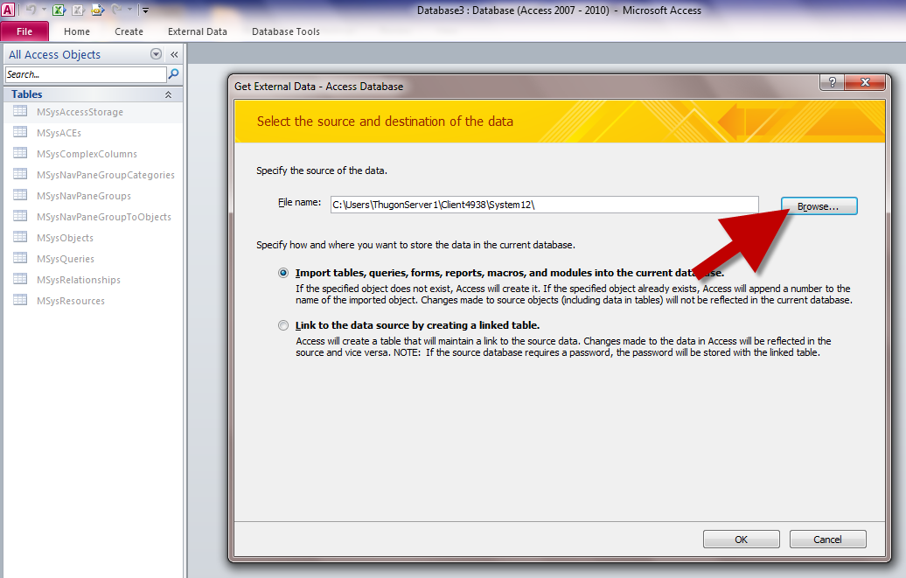

Step #4. Choose the “corrupted” db that you want and click the “ok” button.

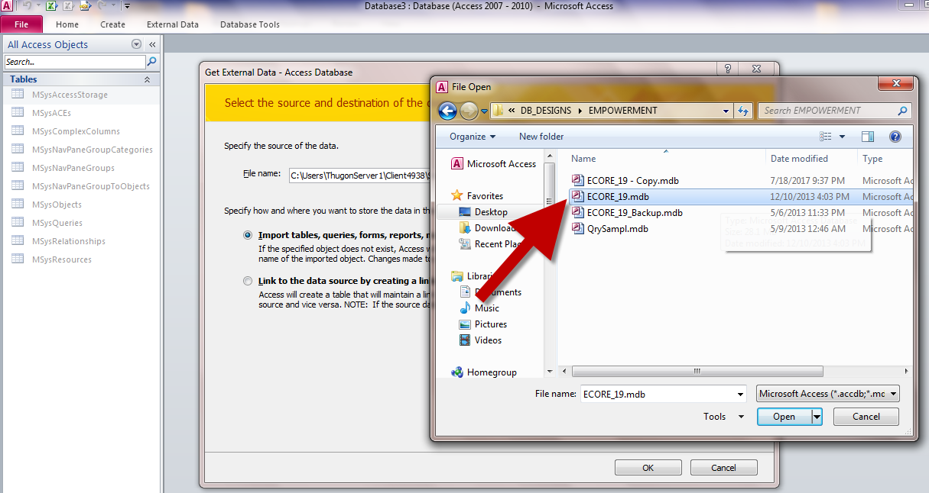

Step #5. You only need the table records. If the db is protected then you will not be able to import modules and other objects. The table records is the only thing you will need. If there is an error, during this step then the db must be repaired first. You can choose to select all the tables and import everything or just tables where you know there are missing data. Click the “ok” button when ready.

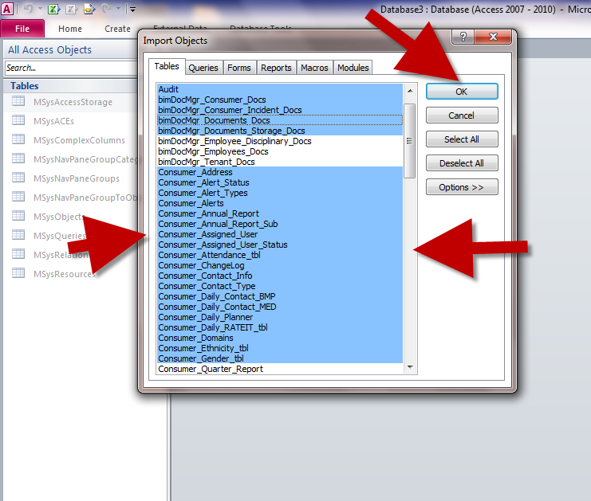

Step #6. If not errors occurs. You will see the following screen “All objects were imported successfully”. Click the “close”. If errors occurred then repair the db first.

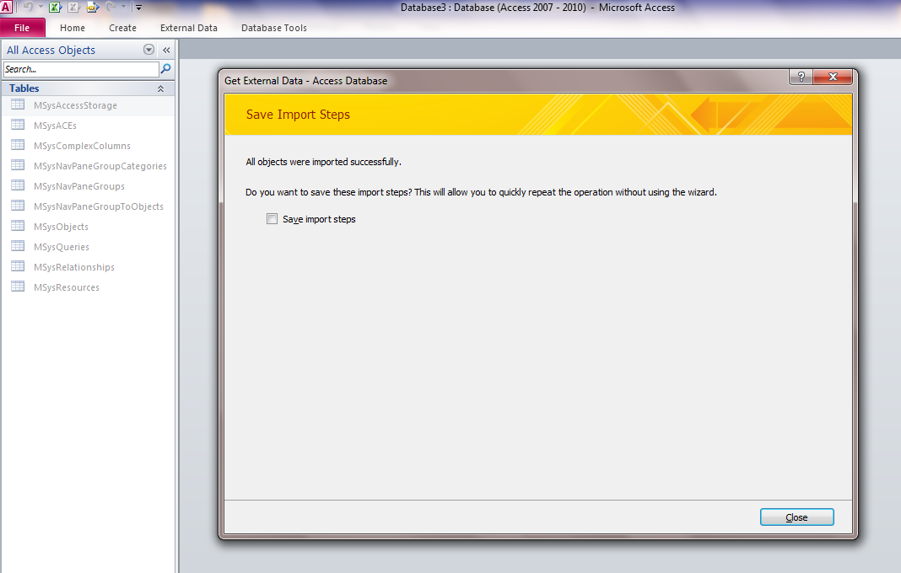

Step #7. The next screen will appear. Notice that all the tables that you had selected are listed in the table. There should be no dublicates.

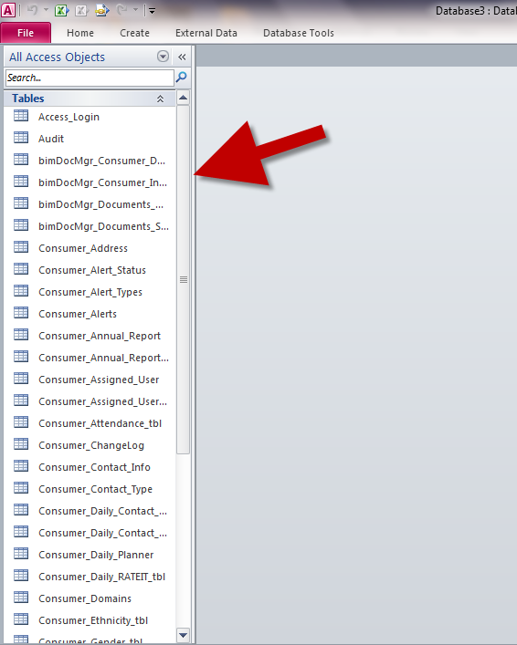

Step #8. Now, We have to import all the data from the “CURRENT DB”. We need to get the new data that was added into this db as well. Use the steps #1 through #6 again. Just point to the “Current db”.

Step #9. Once all the tables from the “Current db” is added, you will see the following on your table listing. Notice that the second time we did the import, the tables are added with a number “1” next to the name. Example; the table Access_Login has another Access_Login1 table as well. You will open both table and copy all the new records from Access_Login1 into Access_Login. Access_Login is the old table that holds the missing data. Access_Login1 holds the newly added data.

This is just an example. Which is why it is easier to know what data is missing. If you do not know what data is missing then you will need to go through every table and look for missing data. Some tables only holds login names or drop down listing and other info that does not need to change.

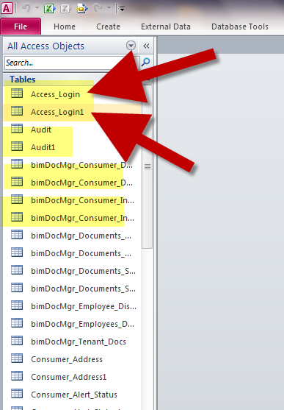

Step #9. Highlight and copy “ONLY” new data from one table to the next and verify the dates. Once you are done with this, then you will import the tables into your “clean” back up db. Since you had added data to the Access_Login table and not the Access_Login1 table, you will be importing the Access_Login. I am just using this as an example only. In your db, you will probably import tables that are labeled Daily_Notes and/or Incidents and etc.

EXAMPLE BELOW. I copied data from the Consumer Address 1 table to the CosumerAddress table.

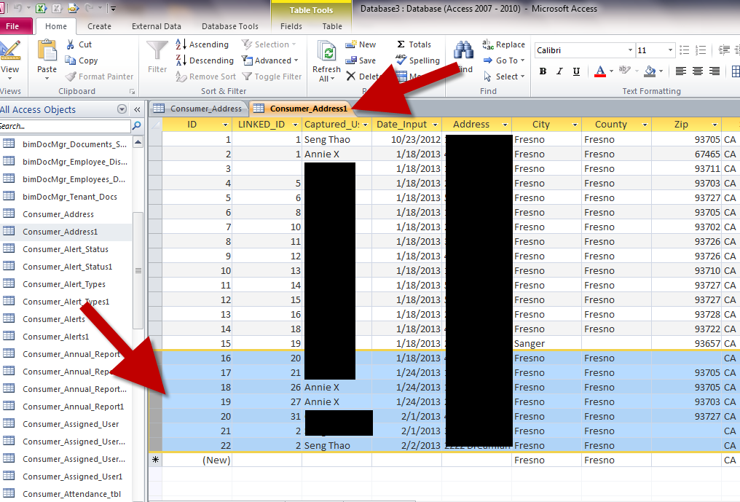

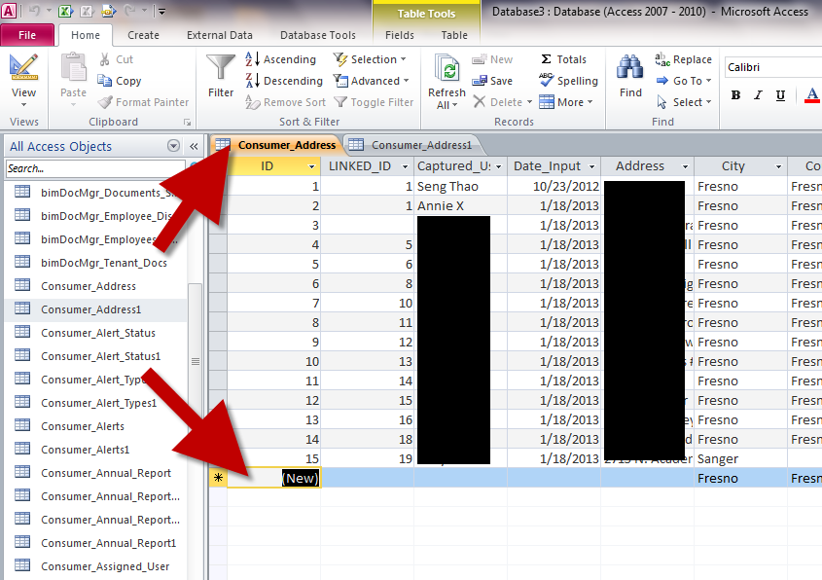

Step #10. Once you are all done with the tables. Compact and repair the db.

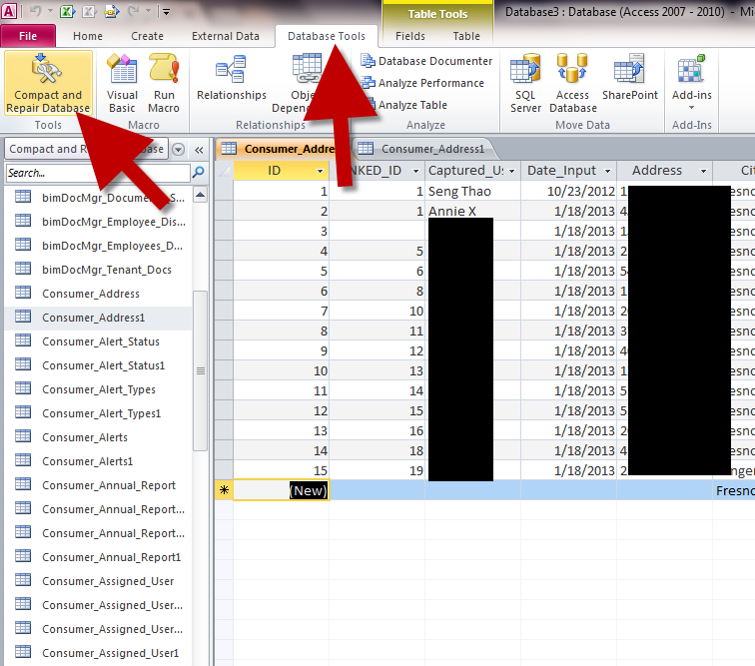

Step #11. If your db is not “PROTECTED” then you can import in all the tables and rename them as the originals.

In this step I will assume that your db is “PROTECTED” and you cannot readily access the tables in the db without exporting them first. You will need to do this one table at a time.

You will open the “blank” db that you have all the new data added to the old data/missing data. Next you will “EXPORT” each table into the good backup copy of your db or you can use the “Current” good db. Which ever is fine.

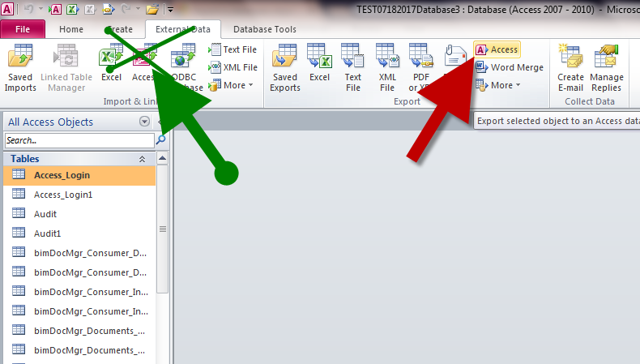

NOTE: We are “EXPORTING” and not importing. You need to use the RED OPTION. DO NOT USE THE GREEN OPTION as I have labeled above.

YOU NEED TO CLICK ON THE TABLE, CLICK ON THE ACCESS EXPORT, CLICK ON THE BROWSE TO WHICH DATABASE YOU WANT THE TABLE TO GO INTO, THEN CLICK OK.

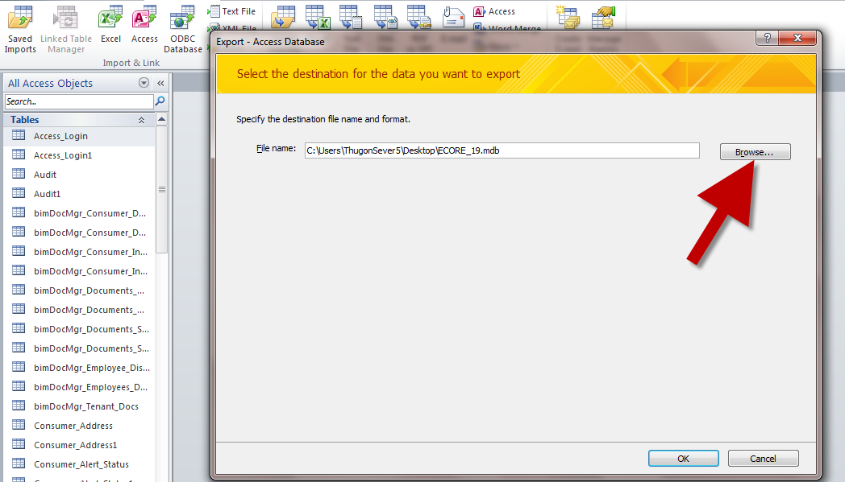

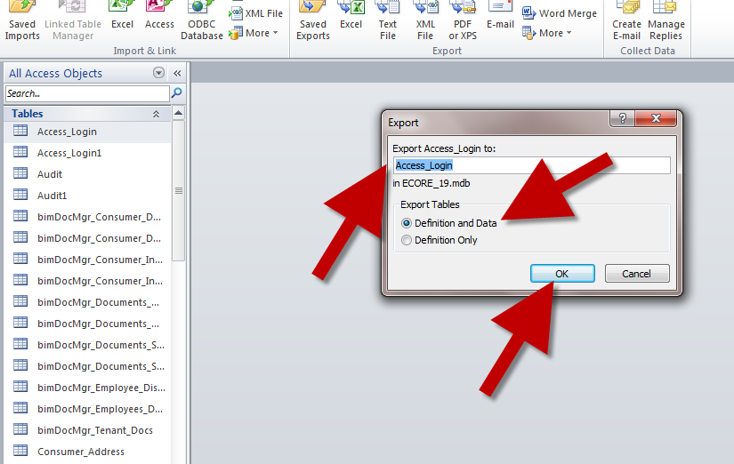

YOU DO NOT NEED TO TYPE IN THE TABLE NAME, KEEP IT THE SAME, IT WILL PROMPT YOU.

Select the Definition and Data option. Then click the ok button. Remember you are exporting to the good db.

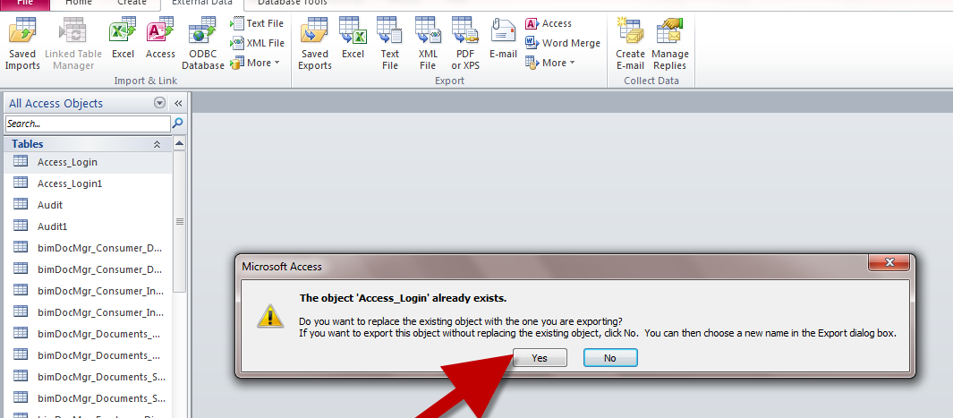

Click the Yes button when prompted if you want replace the existing object.

You need to do this for every table. Once done, compact and repair the current / updated db.

Test and verify the data then deploy.

Questions, let me know.